**AWS :**

**S3 GLACIER VAULT LOCK**

Step 1: go to aws management console and search for s3 glacier in the search bar.

Step 2: Go to Amazon S3 glacier and click on “create vault” .

Step 3: to create vault :

* Firstly ,name the vault then got to next step
* In the next step,set some event notifications but here we kept notifications disabled.
* Then ,review the details and click on “submit”

Step 4: After creating the vault,click on the vault and go to “Vault Policies”.

Step 5: scroll down the vault policies and and click on vault lock policy.In vault lock policy ,click on “Initiate vault lock policy”.

Step 6 : Now for the vault lock policy ,search for “vault lock policies” in aws management console and you will get multiple templates for multiple purposes .Here we get template “Deny deletion permissions for archives less than 365 days old”.

Step 7: Now copy the template and paste into s3 glacier and please do not forget to change the dumpy ARN to ARN of your vault.Then click on “save changes”.

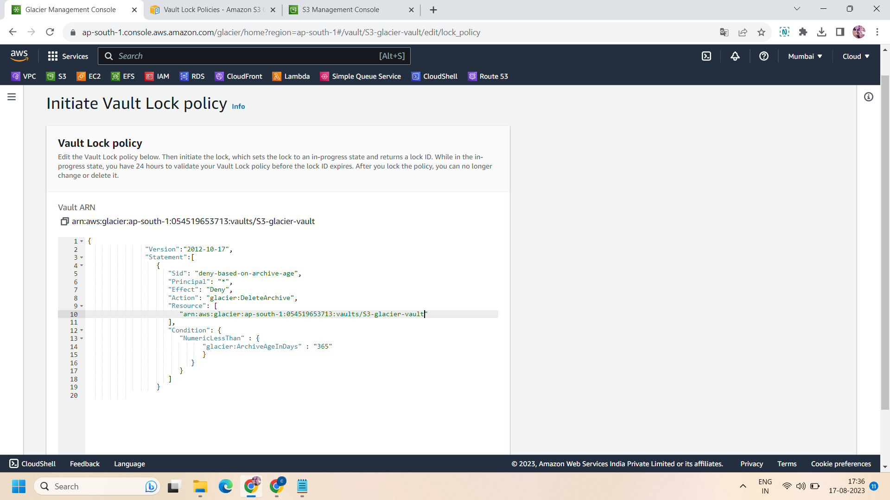

Step 8:After clicking on save changes ,you get a “Lock ID” ,save it at the safest place and click on close.

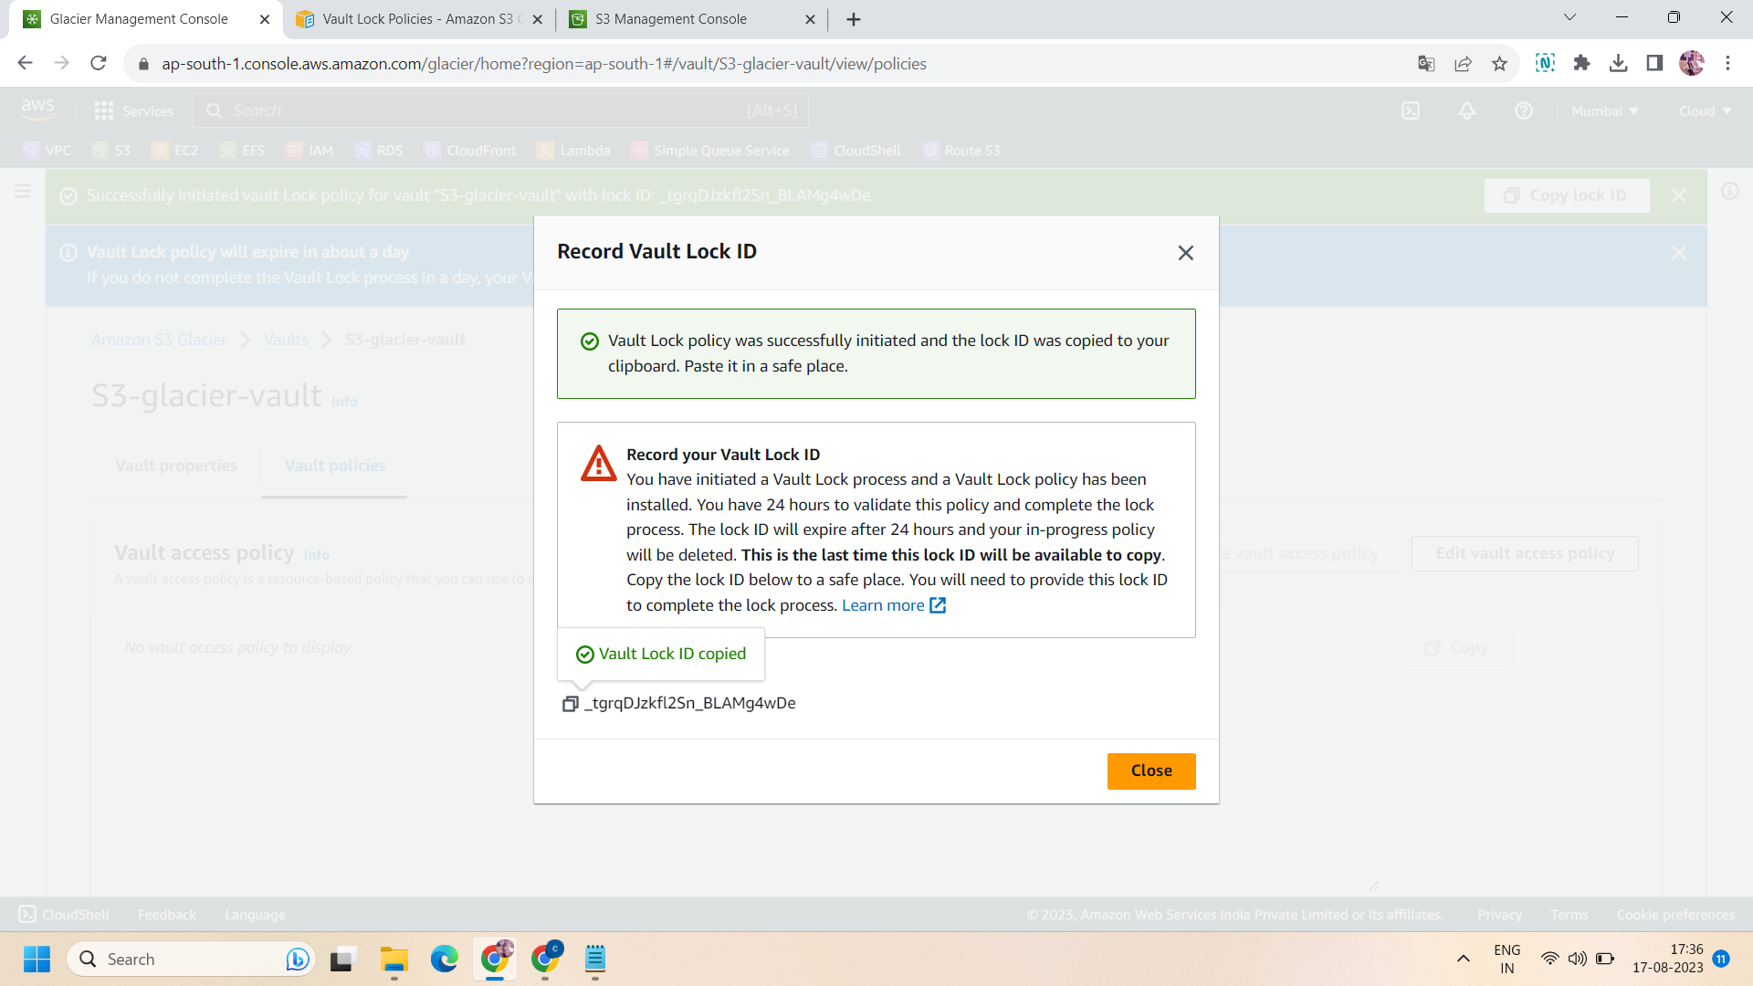

Step 9: now ,if you notice ,vault lock policy status will change from “not locked” to “In-progress”.Now to make it complete ,click on “Complete vault lock policy” .

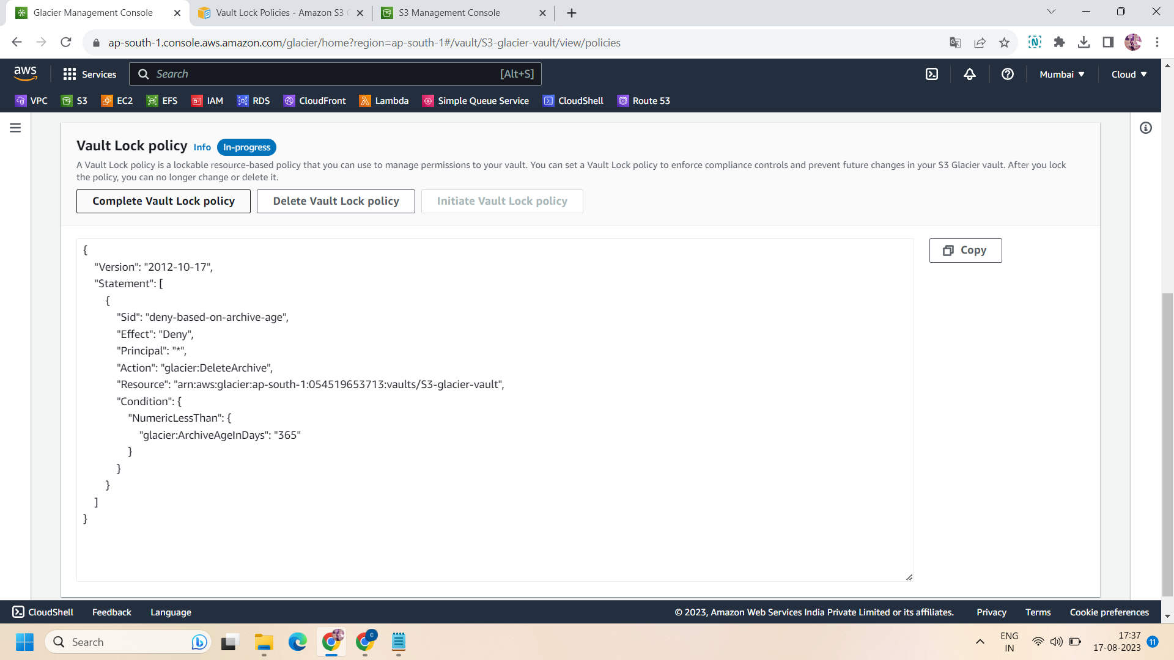

Step 10: On click on complete vault lock policy,it will ask you for lock id ,paste the same id that you save and click on “complete vault lock”.

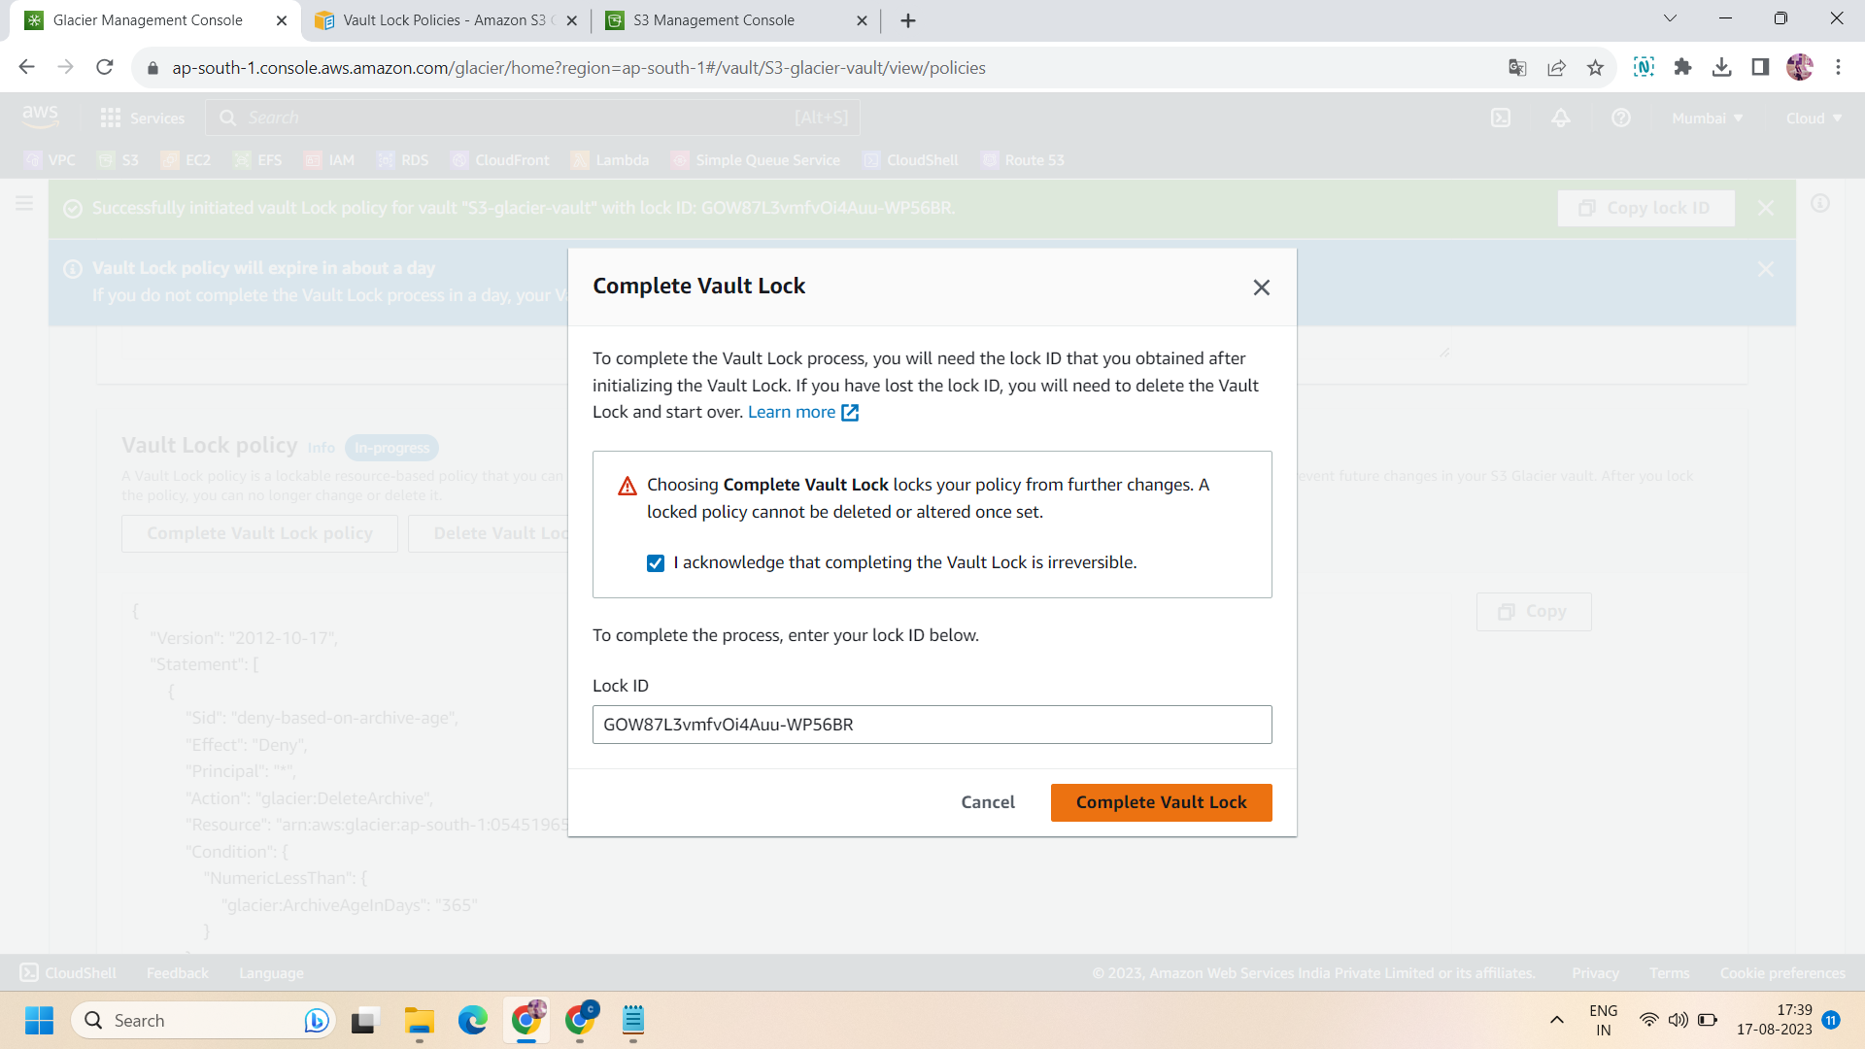

Step 11: Once you click on that ,the status of vault lock policy changes from “in progress” to “Locked” .now all done .!! By this, the vault is responsible to not delete any data that is in the archive and not more than 365 days older.

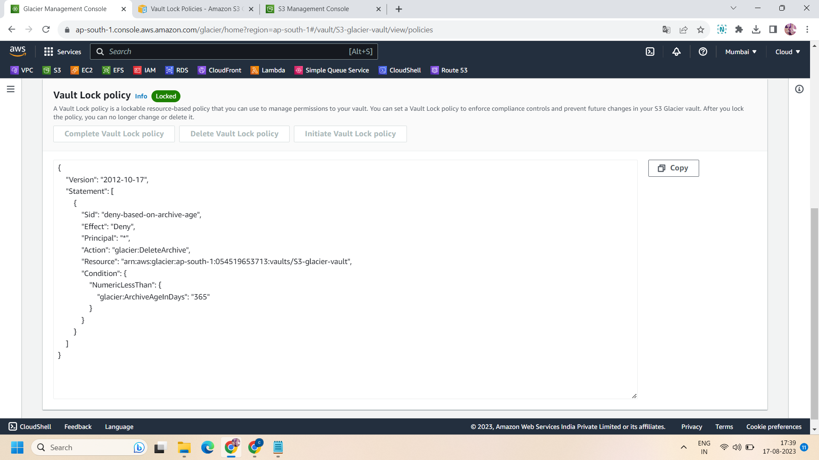

Successfully done!!